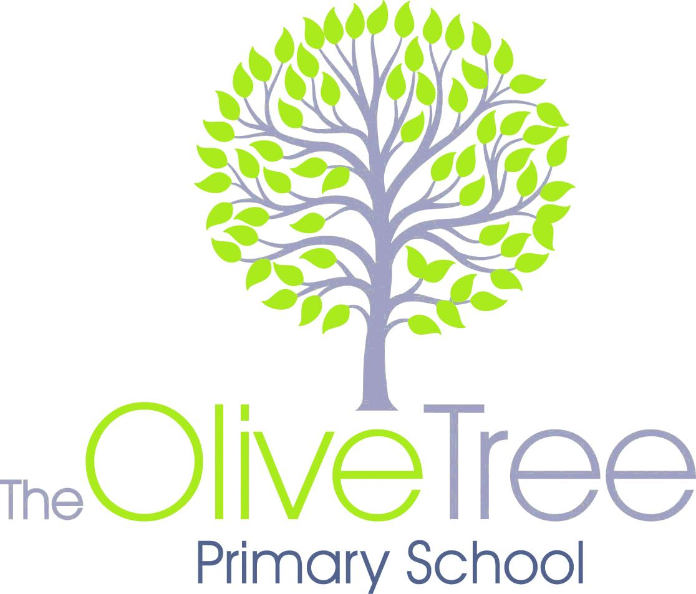

**Reception WYN2K Grid to Parents 2019**

**Expressive Arts and Design**

We are going to act out different jobs and investigate them by making our own scenes and sounds for different emergencies. We will develop our rhythmical skills by clapping or using instruments to develop our skills to describe different textures.

**Personal, Social, Emotional Development**

We will be thinking about who our ‘Helping hands’ are in the classroom. We will be helping our friends learn new skills and develop our interests. We will think about who helps us at home, in the community and in school and how they help us. Also we will begin to learn how to be helpful to those with disabilities.

**Understanding of the World**

This term we will be finding out about lots of different jobs. We will have a range of visitors in school such as the local fire service and the dental nurse to share their job roles. We will also be discussing how we need to look after our class fish!

**Communication & Language**

We will encourage children to ask questions to our visitors, as well as talking about people who help us and how.

**Maths**

We will be looking at different number problems and trying to solve them by ourselves and within small groups. We will continue to practice our counting and number formation. We will start to look at finishing patterns and begin to recognise one more and one less than a number.

**Literacy**

**Reading –** we will read many stories with the theme of ‘Helping Hands’, developing our skills of re-telling the story in the right order and describing events, characters and scenes throughout.

**Writing –** we will be writing many prescriptions throughout the half term. We will continue to practise sounding out words to help us spell in our writing. We will also be labelling different people.

**Arabic**

We will continue to learn the months of the year in Arabic.

**Our Theme unit this half term is:**

Helping Hands

**Physical Development**

We will build our skills balancing on apparatus and joining our movements together.

**Other News or Information:**

**Starting Stimulus:** Class pet: Fish

**Finale:** Visit from Fire Service

**The Oral Dental nurse will be visiting our school on Tuesday 22nd January 2019.**

**ICT Skills**

We will research a range of jobs on Espresso, and use the iPads to support our mathematical knowledge and literacy skills. We will also use QR codes to help us find different people who help us.